**Accomplishment**

List

1. KMemory DDR slave interface √

2. KMemory control interface √

3. Conv

(1) 2x1, 3x1, 5x1 feature/weight read **√**

(2) FC feature/weight read **√**

(3) FC sparsity feature index Undergoing

(4) pad **√**

4. Partial sum aggression: output feature enable

5. PE array enable √

6. Pipeline stage enable √

7. DDR manager

8. 64/32 to 256 bridge

Conv2x1

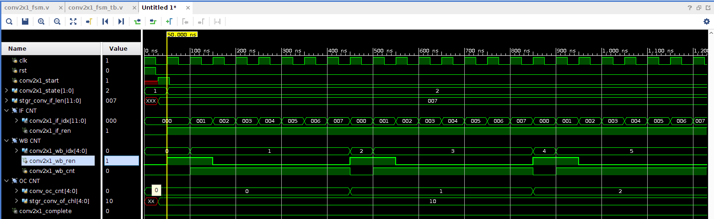

Conv3x1

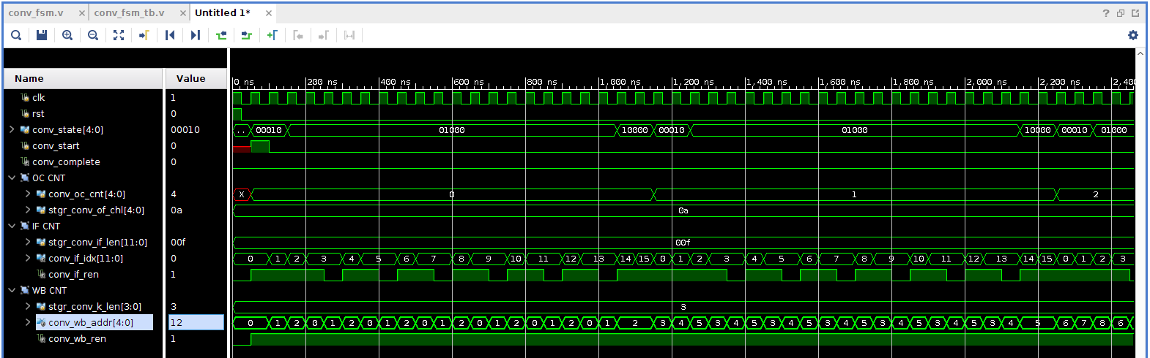

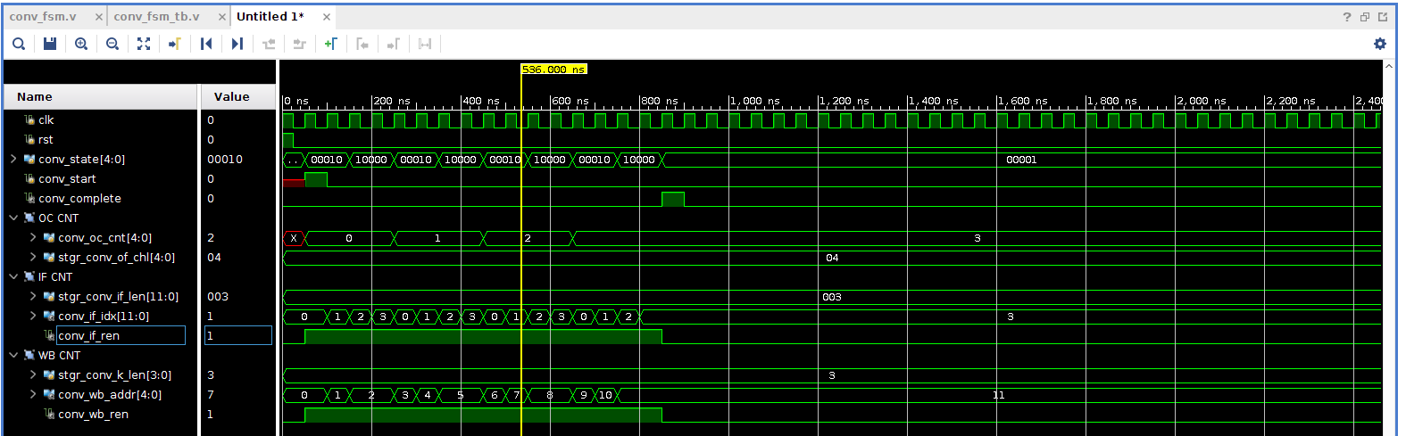

Conv5x1

